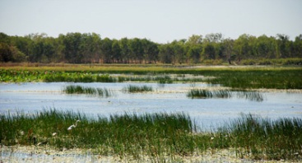

KAKADU
Kakadu is found in the top part of the Northern Territory. Kakadu National Park is an environmental and cultural sanctuary. A UNESCO World Heritage Site, Kakadu National Park is a main tourist destination in the Northern Territory of Australia that covers more than 4.8 million acres.
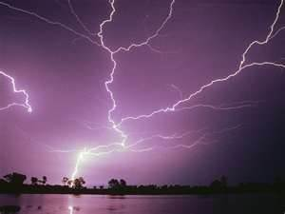
Kakadu got its name from the incorrect pronunciation of an Aboriginal word, Gagudju.
Kakadu has a tropical monsoon climate with two seasons: the dry season and the wet season. The dry season is from April/May until September, the wet season obviously from October until April/May. Most rain falls between January and March (monthly average 300 - 350 mm,), The heavy rain often leads to flooding. Between October and December there are tropical thunderstorms.
The temperatures are highest during the "build up" for the wet season in October/November, with maximum day temperatures often exceeding 40°C and average nightly temperatures around 25°C.
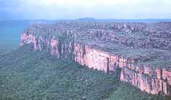
Kakadu is home to a very rich and diverse ecosystem. Major rivers surround and flow in to the area. The East, West, and South Alligator River and the Wildman River are home to a variety of reptile species including the famed Fresh and Saltwater crocodiles.
The park also has six different landscapes which underwent a lot of geological changes millions of years ago. Kakadu's habitats include stone plateaus and escarpments, monsoonal rainforests, flood plains and billabongs, tidal flats, coastal beaches and more, but the vast majority of the area (80%) is covered by open savannah woodlands. The famous waterfalls are Maguk, Gunlom, Twin Falls and Jim Jim Falls
The park also contains the biggest uranium producing mine in the world, the Ranger Uranium Mine.
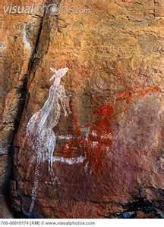
Aborigines have lived in Kakadu for at least 25'000 years. Rock paintings made by the Aboriginal people are still present in the area of Ubirr and Nourlangie. Aborigines painted animals they hunted (some of them are now extinct), tools they used, things they saw (white people are depicted in some newer paintings). Other themes are stories from the creation time, aspects of religious ceremonies, and they also painted to influence people's lives and the future. Big parts of land still belong to the aborigines
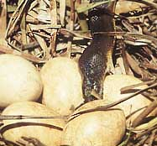
Kakadu’s wildlife is also extensive. Rare species survive in the Yellow Water Billabong, Mamukala Wetlands, Alligator Rivers, Anbangbang Billabong and on the park’s forest. In Kakadu there are 10'000 different species of insects, over 280 bird species (that's one third of all of Australia's bird species), 117 reptile species, 60 species of mammals, 53 species of freshwater fish, The kangaroo, together with wallabies, dingoes, crocodiles, frogs, lizards snakes birds (cockatoos, rosellas) , and insects live in those areas. Most of Kakadu's waterways are inhabited by saltwater crocodiles.
Kakadu has many plants including mangroves, banksia, eucalyptus (gum trees), grevillea, lilies, pandanus and grasses. There are very few weeds.

Landforms | Location | Climate
Animals | Plants | Aborigines

